**N4D8B08 8CH RS485 IO controller commamd**

**MODBUS Command (function code 06 is Control command,03 is Read status command 0x0001-0x0008 registers support 16 (0X10) Command)**

Note :

1 MODBUS command must be HEX

2 Slave ID (device address) must be consistent with the DIP switches (A0-A5)

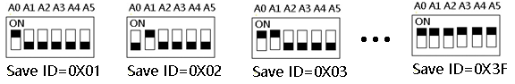

9600 Band ,8 Data bits,None Parity,1 Stop Bit。

Function code

|  |  |  |  |  |
| --- | --- | --- | --- | --- |
| RS485 address  (Station address)  (1) | Function (1) | Register address (2) | Read number (2) | CRC16 (2) |
|  | 03 Read |  |  |  |
|  | 06 Write |  |  |  |
|  | 16(0x10)  Write multiple registers |  |  |  |

|  |  |  |  |  |  |
| --- | --- | --- | --- | --- | --- |
| Function code | Register address | Register contents | Number of bytes | Register value | Remarks |
| 03 06  16(0X10) | 0x0001-0x0008 | Output port status | 2 | 0X0000  0X0001 | 0X0000 Relay Close  0X0001 Relay Open |
| 03 | 0x0081-0x0088 | Input port status | 2 | 0X0000  0X0001 | NPN Input  0X0000 Input Off  0X0001 Input On |
| 03 06 | 0x00FD | Input and output relationship | 2 | 0X0000-  0X0003 | 0x0000 Unrelated  0x0001 Self-locking relationship (default)  0x0002 Interlocking relationship  0x0003 Momentary relationship  Other values are the same as 0 |
| 03 06 | 0x00FE | Baud rate | 2 | 0x0000-0x0005 | 0~5 0:1200  1:2400 2:4800  3:9600（default）  4:19200  5: Factory reset |

**MODBUS** 06 Command (**Control command** ,HEX):

|  |  |  |  |  |  |  |  |  |
| --- | --- | --- | --- | --- | --- | --- | --- | --- |
| Bytes Number | 1 | 2 | 3 | 4 | 5 | 6 | 7 | 8 |
| MODBUS Definitions | Slave ID | Function | Address | | Data | | CRC Check | |
| Function | Device Address | Function | Channel number | | Command | Delay time | CRC Check | |
| Open | 0x00-0x2F | 0x06 | 0x0001-  0x0008 | | 0x01 | 0x00 | 2Bytes CRC | |
| Close | 0x00-0x2F | 0x06 | 0x0001-  0x0008 | | 0x02 | 0x00 | 2Bytes CRC | |
| Toggle (Self-locking) | 0x00-0x2F | 0x06 | 0x0001-  0x0008 | | 0x03 | 0x00 | 2Bytes CRC | |
| Latch Inter-locking) | 0x00-0x2F | 0x06 | 0x0001-  0x0008 | | 0x04 | 0x00 | 2Bytes CRC | |
| Momentary (Non-locking) | 0x00-0x2F | 0x06 | 0x0001-  0x0008 | | 0x05 | 0x00 | 2Bytes CRC | |
| Delay | 0x00-0x2F | 0x06 | 0x0001-  0x0008 | | 0x06 | 0x00-0xff | 2Bytes CRC | |
| Open all | 0x00-0xFE | 0x06 | 0x0000 | | 0x07 | 0x00 | 2Bytes CRC | |
| Close all | 0x00-0xFE | 0x06 | 0x0000 | | 0x08 | 0x00 | 2Bytes CRC | |
| Input and output relationship | 0x00-0xFE | 0x06 | 0x00FD | | 0x0000 Unrelated  0x0001 Self-locking relationship (default)  0x0002 Interlocking relationship  0x0003 Momentary relationship  Other values are the same as 0 | | | |
| Baud rate | 0x00-0xFE | 0x06 | 0x00FE | | 0x00 | 0x00-0x05 |  | |

Remarks:

1 Momentary mode, delay time is 1 seconds

2 Delay mode, delay time is 0-255 seconds

3 0x0001-0x0008 registers not only support 06 function code, but also support 16 (0X10) function code

Return command：

Command is active, return to send commands; instruction is invalid no return.

**MODBUS** 03 Command (**Read status command** ,HEX):

|  |  |  |  |  |  |  |  |  |
| --- | --- | --- | --- | --- | --- | --- | --- | --- |
| Bytes Number | 1 | 2 | 3 | 4 | 5 | 6 | 7 | 8 |
| MODBUS Definitions | Slave ID | Function | Address | | Data | | CRC Check | |
| Function | Device Address | Function | Starting register address | | Register length | | CRC Check | |
| Read Channel 1 State | 0x00-0x2F | 0x03 | 0x0001 | | 0x0001 | |  | |
| Read Channel 2 State | 0x00-0x2F | 0x03 | 0x0002 | | 0x0001 | |  | |
| Read 2 consecutive channels status | 0x00-0x2F | 0x03 | 0x0001-0x0003 | | 0x0002 | |  | |
| Read 3 consecutive channels status | 0x00-0x2F | 0x03 | 0x0001-0x0002 | | 0x0003 | |  | |
| Read all 8 channels status | 0x00-0x2F | 0x03 | 0x0001 | | 0x0008 | |  | |
|  |  |  |  | |  | |  | |
| Read input1 status | 0x00-0xFE | 0x03 | 0x0081 | | 0x0001 | |  | |
| Read input2 status | 0x00-0xFE | 0x03 | 0x0082 | | 0x0001 | |  | |
| Read input3 status | 0x00-0xFE | 0x03 | 0x0083 | | 0x0001 | |  | |
| Read input4 status | 0x00-0xFE | 0x03 | 0x0084 | | 0x0001 | |  | |
| Read the status of 2 consecutive input ports | 0x00-0xFE | 0x03 | 0x0081-0x0087 | | 0x0002 | |  | |
| Read the status of 3 consecutive input ports | 0x00-0xFE | 0x03 | 0x0081-0x0086 | | 0x0003 | |  | |
| Read 8 input port status | 0x00-0xFE | 0x03 | 0x0081 | | 0x0008 | |  | |
|  |  |  |  | |  | |  | |
| Input and output relationship | 0x00-0xFE | 0x03 | 0x00FD | | 0x0000-0x0003 | |  | |
| Baud rate | 0x00-0xFE | 0x03 | 0x00FE | | 0x0000-0x0005 | |  | |

Read status command returns (function code 03, HEX format):

|  |  |  |  |  |  |
| --- | --- | --- | --- | --- | --- |
| Bytes length | 1 | 1 | 1 |  | 2 |
| MODBUS Definitions | Slave ID | Function | data length | data | CRC16 Check |
| Function | Device Address | Function | data length | Relay state  0x0001 open  0x0000 close | CRC16 Check |
| Channel 1  open | 0x00-0x1F | 0x03 | 0x02 | 0x0001 |  |
| Channel 1  close | 0x00-0x1F | 0x03 | 0x02 | 0x0000 |  |
| Channel 2  open | 0x00-0x1F | 0x03 | 0x02 | 0x0001 |  |
| Channel 2  close | 0x00-0x1F | 0x03 | 0x02 | 0x0000 |  |
| Channel 1 open  Channel 2 open | 0x00-0x1F | 0x03 | 0x04 | 0x0001 0x0001 |  |
| Channel 1 open  Channel 2 close | 0x00-0x1F | 0x03 | 0x04 | 0x0001 0x0000 |  |
| Channel 1 close  Channel 2 open | 0x00-0x1F | 0x03 | 0x04 | 0x0000 0x0001 |  |
| Channel 1 close  Channel 2 close | 0x00-0x1F | 0x03 | 0x04 | 0x0000 0x0000 |  |
|  |  |  |  |  |  |
| Input 1 On | 0x00-0xFE | 0x03 | 0x02 | 0x0001 |  |
| Input 1 Off | 0x00-0xFE | 0x03 | 0x02 | 0x0000 |  |
| Input 2 On | 0x00-0xFE | 0x03 | 0x02 | 0x0001 |  |
| Input 2 Off | 0x00-0xFE | 0x03 | 0x02 | 0x0000 |  |
| Input 1 On  Input 2 On | 0x00-0xFE | 0x03 | 0x04 | 0x0001 0x0001 |  |
| Input 1 On  Input 2 Off | 0x00-0xFE | 0x03 | 0x04 | 0x0001 0x0000 |  |
| Input 1 Off  Input 2 On | 0x00-0xFE | 0x03 | 0x04 | 0x0000 0x0001 |  |
| Input 1 Off  Input 2 Off | 0x00-0xFE | 0x03 | 0x04 | 0x0000 0x0000 |  |

MODBUS commands you can use "Modbus Poll" input, as shown below

（CRC check generated automatically）

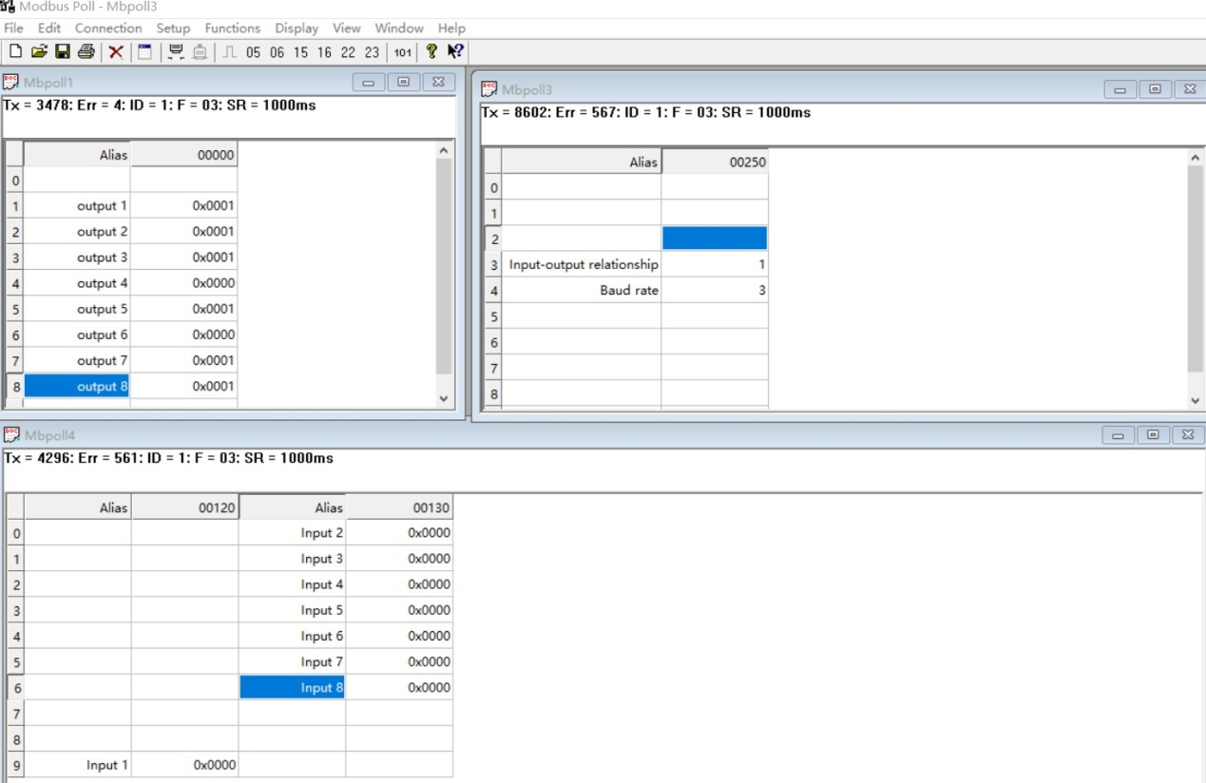

You can also use HyperTerminal serial input, as shown below

（Manually add CRC check）

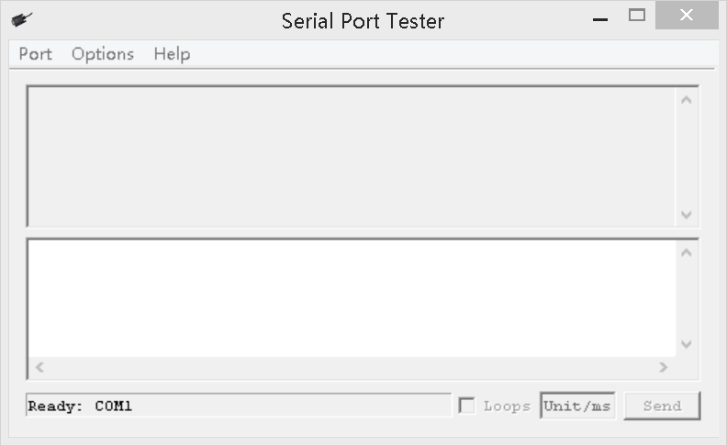

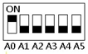

Examples (Slave ID is 1,DIP switch state)

Channel 1 Open ：01 06 00 01 01 00 D9 9A

Channel 1 Close ：01 06 00 01 02 00 D9 6A

Channel 1 Toggle：01 06 00 01 03 00 D8 FA

Channel 1 Latch：01 06 00 01 04 00 DA CA

Channel 1 Momentary: 01 06 00 01 05 00 DB 5A

Channel 1 Delay 10 seconds : 01 06 00 01 06 0A 5B AD

Channel 1 Delay 100 seconds: 01 06 00 01 06 64 DA 41

Channel 2 Open ：01 06 00 02 01 00 29 9A

Channel 2 Close ：01 06 00 02 02 00 29 6A

Channel 2 Toggle ：01 06 00 02 03 00 28 FA

Channel 2 Latch ：01 06 00 02 04 00 2A CA

Channel 2 Momentary : 01 06 00 02 05 00 2B 5A

Channel 2 Delay 10 seconds : 01 06 00 02 06 0A AB AD

Channel 2 Delay 100 seconds : 01 06 00 02 06 64 2A 41

Open all：01 06 00 00 07 00 8B FA

Close all：01 06 00 00 08 00 8E 0A

16 (0X10) function code (only supports 0x0001-0x0008 registers)

Open all：01 10 00 01 00 08 10 01 00 01 00 01 00 01 00 01 00 01 00 01 00 01 00 89 3A

Close Channels1-4：01 10 00 01 00 04 08 02 00 02 00 02 00 02 00 CB 5A

Close Channels 5-8：01 10 00 05 00 04 08 02 00 02 00 02 00 02 00 3A 95

Read state (assuming that the channel 1 is open, the channel 2 is close).

Read channel 1 state ：01 03 00 01 00 01 D5 CA

Return open：01 03 02 00 01 79 84

Read channel 2 state ：01 03 00 02 00 01 25 CA

Return close：01 03 02 00 00 B8 44

Read channel 1 and channel 2 state ：01 03 00 01 00 02 95 CB

Return channel open and channel 2 close ：01 03 04 00 01 00 00 AB F3

Read 1-8 channel input status：01 03 00 81 00 08 14 24

Return all input channels OFF：01 03 10 00 00 00 00 00 00 00 00 00 00 00 00 00 00 00 00 E4 59

Return input channel 1 ON：01 03 10 00 01 00 00 00 00 00 00 00 00 00 00 00 00 00 00 25 59

1. **Read baud rate**

Send data

|  |  |  |  |  |
| --- | --- | --- | --- | --- |
| RS485 address  (Station address)  (1) | Function (1) | Register address (2) | Read number (2) | CRC16(2) |

Returns data

|  |  |  |  |  |
| --- | --- | --- | --- | --- |
| RS485 address  (Station address)  (1) | Function (1) | Number of bytes (1) | data (n) | CRC16(2) |

Function code 0x03

Register address：0x00FE

Read number：0x0001

For example:

send data(RS485 address is 1)：01 03 00 FE 00 01 E5 FA

Returns data：01 03 02 00 03 F8 45

01 RS485 address，03 Function，02 length，F8 45 crc16

03 means the current baud rate is 9600bps

Baud rate corresponds to the number: 0: 1200 1: 2400 2: 4800 3: 9600 4: 19200

1. **Write baud rate**

Send data

|  |  |  |  |  |
| --- | --- | --- | --- | --- |
| RS485 address  (Station address)  (1) | Function (1) | Register address (2) | Setting Content (2) | CRC16(2) |

Returns data

|  |  |  |  |  |
| --- | --- | --- | --- | --- |
| RS485 address  (Station address)  (1) | Function (1) | Register address  (2) | Register value (2) | CRC16(2) |

Function code 0x06

Register address：0x00FE

Setting Content：2Bytes(0-4)

For example, Change the baud rate to 4800bps:

send data(RS485 address is 1)：01 06 00 FE 00 02 69 FB

Returns data：01 06 00 FE 00 02 69 FB

Baud rate corresponds to the number: 0: 1200 1: 2400 2: 4800 3: 9600 4: 19200

5: Factory reset

Note: 1 The baud rate will be updated when the module is powered up again!

2 The factory setting can be restored when the baud rate corresponding to the number is 5. For example: 01 06 00 FE 00 05 28 39

1. **Read input and output relation register**

Send data

|  |  |  |  |  |
| --- | --- | --- | --- | --- |
| RS485 address  (Station address)  (1) | Function (1) | Register address (2) | Read number (2) | CRC16(2) |

Returns data

|  |  |  |  |  |
| --- | --- | --- | --- | --- |
| RS485 address  (Station address)  (1) | Function (1) | Number of bytes (1) | data (n) | CRC16(2) |

Function code 0x03

Register address：0x00FD

Read number：0x0001

For example:

send data(RS485 address is 1)：01 03 00 FD 00 01 15 FA

Returns data：01 03 02 00 01 79 84

01 RS485 address，03 Function，02 length，15 FA crc16

Register corresponding value:

0x0000 Unrelated

0x0001 Self-locking relationship (default)

0x0002 Interlocking relationship

0x0003 Momentary relationship

Other values are the same as 0

1. **Write input and output relation register**

Send data

|  |  |  |  |  |
| --- | --- | --- | --- | --- |
| RS485 address  (Station address)  (1) | Function (1) | Register address (2) | Setting Content (2) | CRC16(2) |

Returns data

|  |  |  |  |  |
| --- | --- | --- | --- | --- |
| RS485 address  (Station address)  (1) | Function (1) | Register address  (2) | Register value (2) | CRC16(2) |

Function code 0x06

Register address：0x00FD

Setting Content：2Bytes(0-3)

For example, Set the input and output to be unrelated, and change the register value to 0X0000:

Send data(RS485 address is 1)：01 06 00 FD 00 00 18 3A

Returns data：01 06 00 FD 00 00 18 3A

Register corresponding value:

0x0000 Unrelated

0x0001 Self-locking relationship (default)

0x0002 Interlocking relationship

0x0003 Momentary relationship

Other values are the same as 0